General Purpose Mounting Block B
Version 1.0

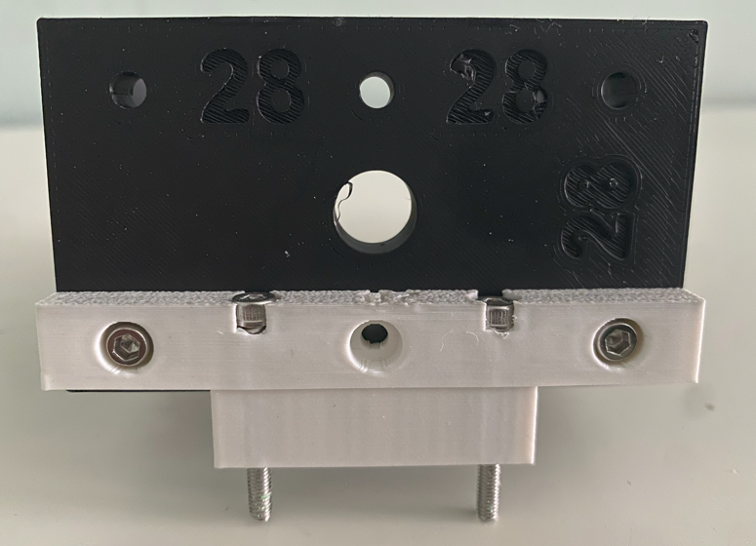

Project Goals
I need to create a block that can rotate 90 degree the fixing screw angle.
I need something that fit into the Kaiser Stand Bracket and let me fix something from the bottom.
This is Block B that is the slim one.

Sketch

Top View
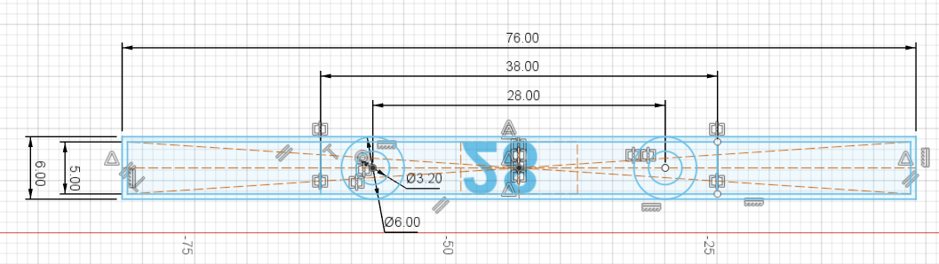

Side view
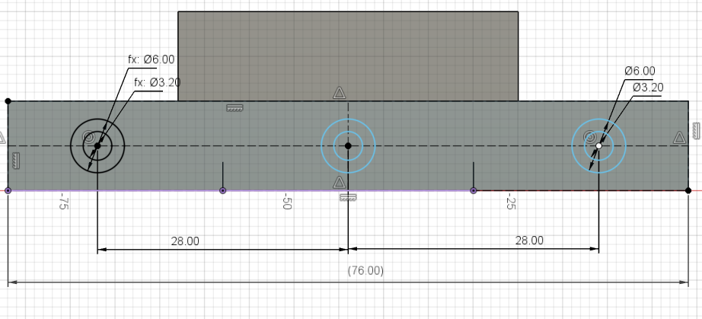

3D Model
The thickness is 6 mm in the top side and just 5 in the lower part.
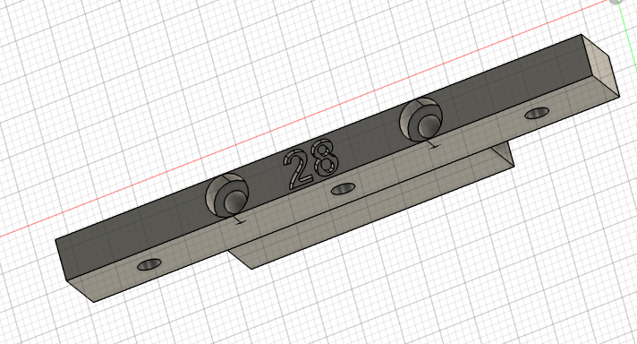

3D Printer Layout

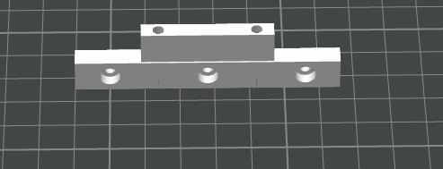

Final result
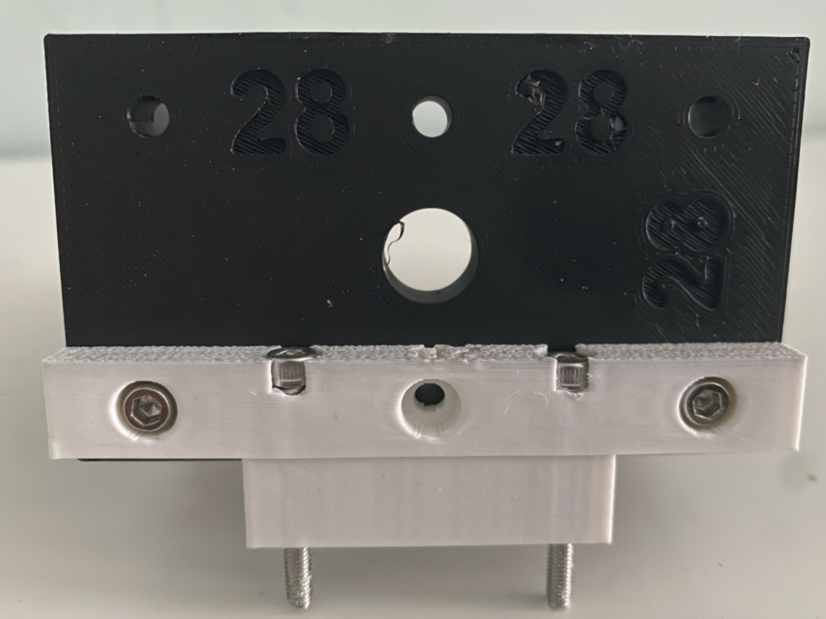 | 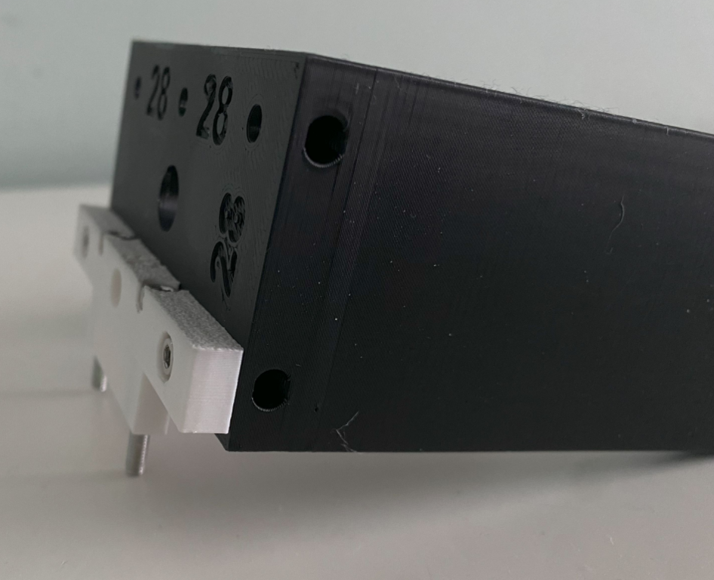

Reference

Kaiser Stand Bracket
This component is to be used with the KaiserStandBracket v3.0.
